SIMATS ENGINEERING (SAVEETHA SCHOOL OF ENGINEERING)
Department of Computer Science and Engineering
ASSESSMENT TOOL 1 – Coding Challenge Task
Course Code: | CSA06 | Course Title: | Design and Analysis of Algorithms
CO Assessed: | CO4: Articulation (BL4, BL5) | Assessment: | Assessment Tool 1 – Coding Challenge Task
Weightage: | 40% of CIA | Total Marks: | 100
CO4 Statement: | Solve optimization problems using dynamic programming and greedy strategies.
Student Name: | Dinesh Karthick R | Reg. No.: | 192524121
Section / Batch: | 02 | Date: | 20-08-2026

Instructions to Students
- Answer the following question. Total Marks: 100.
- Carefully analyze the given questions.
- Write clear code for the given problem.
- Analyze the Time complexity and Space complexity of your code using dynamic programming and greedy strategies

Question Type | Focus Area | Questions
Coding Challenge Task | Focus on Code and analyze optimization problems using dynamic programming and greedy strategies | Q1

SECTION A – Coding Challenge Task
Q1 Maximum Sum Subarray 100 marks
Given an array of integers containing both positive and negative values, find the contiguous subarray that has the largest possible sum. The chosen elements must appear consecutively in the original array. The objective is to determine the maximum sum that can be obtained from any such subarray. Use Dynamic Programming to compute the optimal result efficiently.
Input Format:
n = number of elements
arr[] = array elements
Code of Conduct
I Dinesh Karthick R / 192524121 (Name / Reg No) certify that this submission is my original work and that I have adhered to the guidelines specified for this assessment. I understand that any violation of academic integrity rules will result in disciplinary action.
Signature of the Student: _________________________

RUBRICS FOR CALCULATION
Coding Challenge Task
Criteria | Weightage | Level 4 (Exemplary) | Level 3 (Proficient) | Level 2 (Developing) | Level 1 (Beginning)
Problem Understanding | 20% | Clearly understands problem constraints, edge cases, and competitive requirements | Understands problem with minor gaps in constraints | Partial understanding; misses key constraints | Misinterprets problem or constraints
Algorithm | 25% | Selects optimal algorithm with best time and space complexity for competitive constraints | Uses efficient algorithm with minor scope for improvement | Uses basic/inefficient approach | No clear algorithmic approach
Code Implementation | 20% | Writes correct, efficient, and clean code that passes all constraints | Code works with minor errors or inefficiencies | Partially correct code; fails for some cases | Code does not execute or gives incorrect results
Competitive Performance | 20% | Solves problem within time limits and handles large inputs effectively | Solves within acceptable time with minor delays | Struggles with time limits or larger inputs | Unable to solve within time constraints
Test Case Handling | 15% | Handles all test cases including edge and hidden cases | Handles most test cases | Misses important edge cases | Fails on multiple test cases

Marks Evaluation:
Criteria | Wt. | Level 4 – Exemplary | Level 3 – Proficient | Level 2 – Developing | Level 1 – Beginning
Problem Understanding | 20%
Algorithm | 25%
Code Implementation | 20%
Competitive Performance | 20%
Test Case Handling | 15%
Total Marks (100):

Faculty In-charge | Course Coordinator | Head of Department
Name: ____________________ | Name: ____________________ | Name: ____________________
Signature: ____________________ | Signature: ____________________ | Signature: ____________________
Date: ____________________ | Date: ____________________ | Date: ____________________

Appendix – Submission Screenshot
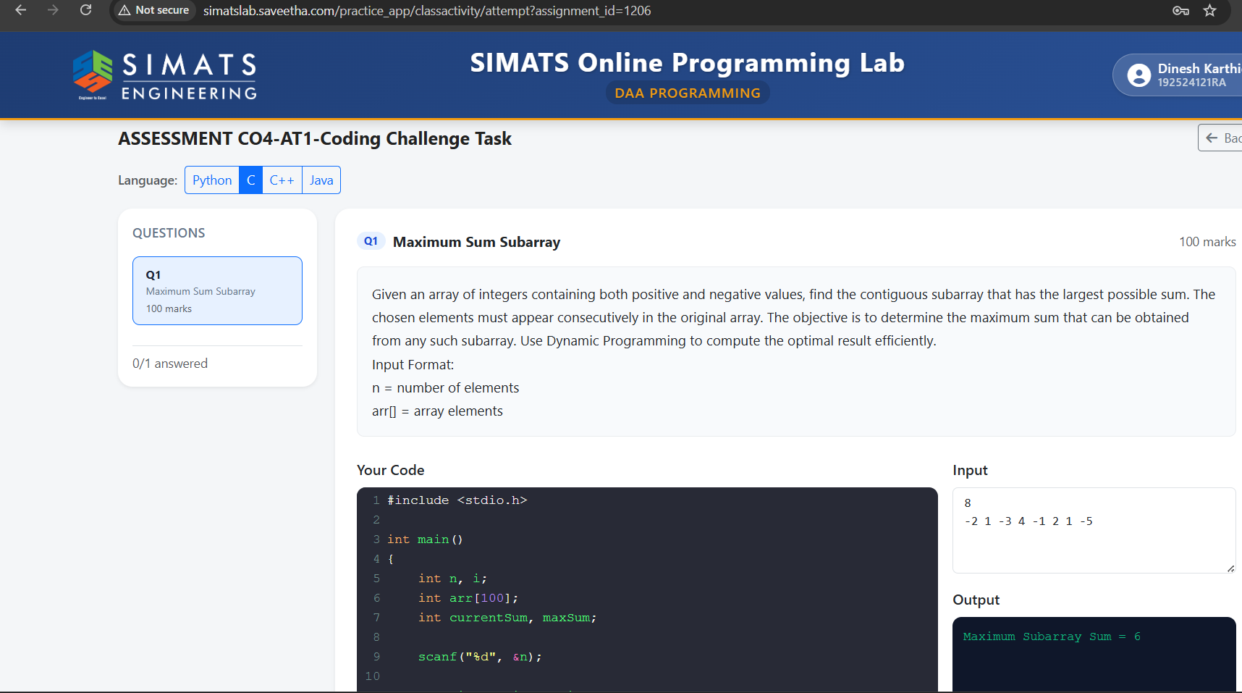

Appendix – Submission Screenshot (contd.)
